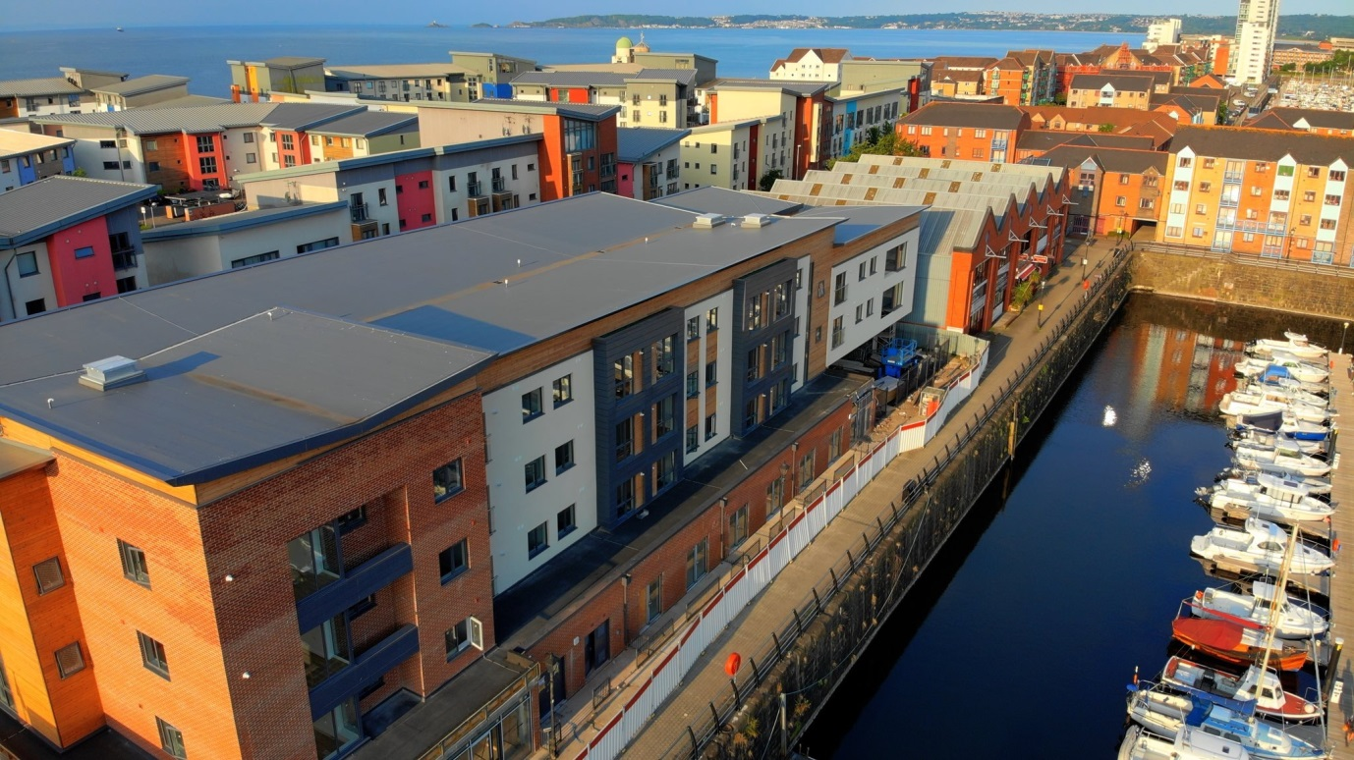

**Trawler Road Residential Development – 50 Apartments**

**Design, manufacture and erection of a residential apartment complex situated in the SA1 area of Swansea. Constructed in 2017, Seven Oaks provided the timber frames, floor cassettes and flat roof structure for 50 apartments on this development. The timber frame structure of 3 storeys sits on a ground floor steel frame transfer slab.**

**Type of Project – Residential/Social Housing**

**Client – Jehu Project Services**